Product-Driven Software Product Line Engineering
Steffen Zschaler, Pablo Sánchez, Carlos Nebrera, Lidia Fuentes, Vaidas Gasiunas, Ludger Fiege

Introduction
The previous chapters of this book presented a number of different techniques that are useful for developing software product lines (SPLs). These techniques can be combined in a variety of ways for different SPLs; each SPL is likely to require its own combination of techniques. To provide some guidance for SPL engineers, this and the next two chapters discuss different scenarios for product-line development and explain which of the techniques previously presented can be used in which way in this scenario.
This chapter focuses on product-driven SPL engineering. We begin by explaining what we mean by this term, followed by an identification of requirements for this SPL scenario and a description of an approach for systematically developing such SPLs. The chapter closes by discussing the approach and how it meets the initial requirements as well as the challenges discussed in Chapter 1.

Product-Driven Software Product Line Engineering
SPLs can be useful in a broad spectrum of contexts. Based on the underlying business model, we can identify the following two contexts as the limits of this spectrum (see also Figure 1):
- Product-Driven SPL Business: Here, the SPL is used to manage a suite of products, each of which is sold to a number of clients. The number of products in the product suite is largely stable, although some changes may occur over time. However, new features are added to the product line (and thus to all or only some products in the product suite) as the SPL evolves. An example for such a product line is a suite of applications for mobile phones; depending on the specific phone on which an application is to be deployed, different features may be enabled or disabled. The main goal in any SPL setting is to reduce the cost of developing individual products by easing reuse and, ideally, automating product derivation from an SPL architecture and asset base. In a product-driven context, facilitating maintenance and evolution of the SPL as a whole gains more importance, as the number of products is limited so that the cost of initial production is outweighed over time by the cost of maintenance and evolution of all or a subset of the products. Maintenance and evolution can be facilitated, for example, by providing appropriate structure to the SPL and documenting precisely which parts of the SPL architecture relate to which feature so that product creation can ideally be automated when new features are introduced or the implementation of existing features evolves.
- Solution-Driven SPL Business: In this context, the SPL is used to manage similar products, but where the commonalities and differences among products can not be so clearly identified. This might be because that the different products to be sold are not known when setting up the SPL or because products vary largely among them and it is not trivial to identify common and variable features. Each product is typically only sold once, as a solution to a specific problem in a domain, and, contrarily to product-driven SPL, each product cannot be automatically constructed by simply selecting what features must be included in it. Each product often requires a dedicated effort developing elements or features that are product-specific, that is, that cannot be reused by any other product. A typical example for this scenario is a product line of Internet presences for small and medium-size enterprises (SMEs). While all products are more or less similar, every such web site is special and requires its own particular features, which are specific to a concrete website and cannot be reused for any other website. However, all products share certain characteristics that are determined by the domain. It is therefore useful to manage them together under the common umbrella of an SPL. In contrast to product-driven SPL engineering, in a solution-driven context the focus is more on enabling as much reuse as possible and on enabling reuse in a structured way, as a replacement for the “copy & paste” reuse often found in practice.
Clearly, the two scenarios outlined above are very polar and do not necessarily occur in reality in their pure form. Instead, different mixed forms are much more likely to occur (see Figure 1 for an overview of the complete spectrum). Still, understanding these polar forms may help us improve our understanding of the mixed forms.
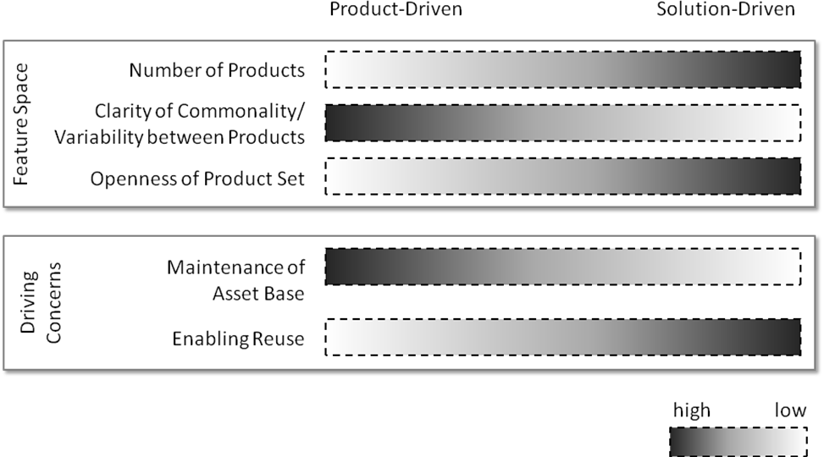
Figure 1 SPLs as a spectrum between product- and solution-driven scenarios
In this chapter, we focus on product-driven SPL engineering. The next chapter discusses solution-driven SPL engineering in more detail. In the following section we discuss the requirements a product-driven context places on SPL engineering before proposing an integrated approach to developing SPLs in a product-driven context in Sect.5.

Requirements for a Product-Driven Software Product Line Engineering Approach
As mentioned above, in product-driven SPL engineering facilitating management and composition of variable features becomes more important. This leads to the following requirements for a product-driven SPL engineering approach (in addition to the five core SPL challenges discussed in Chapter 1):
- Strong support for variability identification, specification and design. For variability identification and specification, feature models as introduced in the context of the Feature-Oriented Domain Analysis (FODA) (Kang, Cohen, Hess, Novak, & Peterson, 1990) are a useful way of expressing variability. When designing a SPL, it is important to not only represent the common core of the product line, but to also design the variations to encode as much information as possible about the individual products and leave as few decisions as possible to application engineering (Gomma, 2004).
- Strong support for feature management and composition throughout the SPL. In order to be able to add (or remove) features for specific products as requested by customers, it is essential that developers be able to trace each feature throughout all models and code of the SPL. Beyond providing adequate tracing information as discussed in Chapter 8, ideally an SPL’s architecture and implementation should be structured in such a way as to make it easy to identify and compose architectural elements and code parts responsible for realising a particular feature.
- Strong automation support for application engineering. Automation may provide substantial economic benefits. Unfortunately, domain engineering is a highly creative process, so is difficult, or even impossible, to automate. However, in a product-driven setting, automation at the application-engineering level may already provide great benefits. At this level it should be well-defined how to compose different features into a specific product. Ideally, once domain engineering has been finished, it should be possible to generate individual products completely automatically given a product configuration (a specific selection of features defined in a feature model) and the artefacts developed in domain engineering.
Orthogonally to these requirements, different SPLs are developed from a different base: So-called pro-active SPLs are conceived and developed as a product line from the very beginning, while reactive SPLs are based on a number of similar products that could benefit from being maintained and evolved in an SPL framework. Note that these notions are completely orthogonal to the product-driven vs solution-driven distinction between different types of SPLs. Hence, ideally a development approach for product-driven SPLs would support both pro- and reactive SPL development.
In the following we present TENTE, an approach that strives to address these requirements as well as the challenges from Chapter 1. Before that, however, we discuss some related work from the literature to provide an understanding of how these requirements are or are not met by existing approaches.

Related Work
There are several commercial tools, such as pure::variants or Gears, which target the automation of Software Product Line product derivation processes. However, they focus on the implementation level. The architectural stage is not considered. These tools would need to be significantly extended for dealing with architectural models, these extensions being not trivial as these tools are often based on XMI-based manipulations.
Ziadi and Jézéquel (Ziadi & Jézéquel, 2006) and Czarnecki and Antkiewicz (Czarnecki & Antkiewicz, 2005) address the automation, by means of model transformations, of the derivation of architectural/detailed design models for specific products from models that represent the complete family of products. However, these works do not deal with the transformation of these models into an implementation. They do not also consider the separation of coarse-grained variants using advanced mechanisms for separation of concerns.
Voelter and Groher (Völter & Groher, 2007) presents an approach that combines aspect-oriented and model-driven techniques in an SPL process. Coarse-grained variants are separated as aspects using xWeave, a tool of the openArchitectureWare suite. Nevertheless, the separation of variants is lost at the implementation level, where the target language is plain Java. Moreover, automation is only supported at the application engineering level.
Laguna et al (Laguna, González-Baixauli & Marqués. 2007) present a seamlessly process for Software Product Line engineering where coarse-grained variants are separated in UML packages combined by merge operators at the architectural level. These UML packages are managed at the implementation level as separated projects, where classes are implemented as partial C# classes. Laguna et al (Laguna et al., 2007) use UML packages and UML merge as the unique mechanism for dealing with variability and no automation is provided for other techniques. UML package merge is only suitable for coarse-grained variants (Loughran, Sánchez, Garcia, & Fuentes, 2008), leading to scalability problems when applied to fine-grained variants, such as for instance, a light dimmer in a SmartHome having a digital display or not.
Trujillo et al (Trujillo, Batory, & Díaz, 2007) presents a MDD process for portlet development. A portlet is a third-party component for the development of web applications. This MDD process is extended for the development of Software Product Lines of portlets. Variable features or variants of a portlet are separated from the core part of the portlet. Model transformations are applied to each variant, obtaining the implementation skeletons for that variant. These skeletons are manually completed. In order to synthesise a product, the implementation of the selected variants are combined with the core. Thus, product derivation is carried out only at the implementation level. Thus, models of specific products are not obtained. Moreover, this approach is specific for portlets.
Our approach, compared to the work of Laguna et al (Laguna et al., 2007) and Trujillo et al (Trujillo et al., 2007), benefits of a more powerful type system provided by CaesarJ, which eases the management of dependencies between features, support direct feature instantiation and the polymorphic use of features, amongst other issues (Aracic, Gasiunas, Mezini, & Ostermann, 2006; Gasiunas & Aracic, 2007).
As conclusion, we can state there is no approach that satisfies our requirements, although approaches such as Laguna et al (Laguna et al., 2007) or Trujillo et al (Trujillo et al., 2007) are closed to what we want to achieve.

The TENTE Approach
This section describes TENTE (Fuentes, Nebrera, & Sánchez, 2009), a product-driven Software Product Line approach. TENTE is a feature-oriented model-driven process integrating different AMPLE tools, languages and technologies: TENTE uses the output of the AMPLE requirements engineering tools and languages, such as Arborcraft (see Chapter 3) and VML4RE (see Chapter 4), for constructing a feature-oriented architectural model according to the AMPLE guidelines (Sánchez, Gámez, Fuentes, Loughran, & Garcia, 2007). The link between variability models and the software architectural models is specified using VML4Arch (see Chapter 4). Using automatic code generators, TENTE produces code for the ECaesarJ language (see Chapter 6), both at the domain and the application engineering level. During this code-generation process, TENTE also generates trace links, which are stored in the AMPLE Traceability Framework (ATF) (see Chapter 8).
TENTE comprises the architectural design and the implementation stages, both at domain and application engineering levels. It fits especially well with the requirements engineering approach created in the context of the AMPLE project, but, since it was designed to have a certain degree of independence from any requirements engineering approach, it could be used with other requirements engineering techniques. In general, TENTE requires that the requirements engineering technique used generates as output a (cardinality-based) feature model, or other form of variability model, such as a DSL, plus a requirements specification and/or one or more requirements models. In the context of the AMPLE project, this is provided by Arborcraft, which generates a feature model from documents where requirements are expressed in natural language, plus a requirements specification in RDL (see Chapter 3). Using this RDL specification, several requirements models, using UML use cases and activity diagrams might be constructed. In this case, VML4RE would be used for linking the feature model with the requirements models (see Chapter 4). TENTE would use this information for manually constructing the reference architecture of the SPL.
In TENTE, coarse-grained variants are encapsulated into separate model fragments, according to the AMPLE architectural design guidelines (Sánchez et al., 2007), both at the domain and application-engineering levels. This leads to a better modularisation (Greenwood, Bartolomei, et al., 2007), which eases variability management, maintenance and evolution. By coarse-grained variant, we mean a variable feature of a Software Product Line, related to a coherent set of functionality, which implies the addition of new components/classes, or non-trivial modifications to a set of components/classes that are part of the Software Product Line architectural design or implementation. For instance, considering the Smart Home case study from Chapter 2, the automatic light management is considered a coarse-grained variant.
Furthermore, TENTE uses model-driven techniques to partially automate the domain-engineering process and fully automate application engineering. Models for the specific family of products being developed are explicitly maintained at the domain-engineering level, contrarily to other model-driven SPLE approaches. For example, MAPLE (see Chapter 11), encodes most architecture information implicitly in a set of model transformations, rather than using generic transformations parameterised by models of the SPL architecture.
The TENTE process is comprised of five steps, as depicted in Figure 2. It covers the architectural design and implementation software development stages, both at the domain and application engineering levels. Software architectural models are expressed in UML 2.0, following the AMPLE architectural design guidelines (Sánchez et al., 2007). The implementation language selected is CaesarJ (Aracic et al., 2006) (see Chapter 6), a language with special features, such as virtual classes and mixin composition, for Feature-Oriented Programming (FOP) (Gasiunas & Aracic, 2007). The steps of the process are described in more detail in the following subsections.
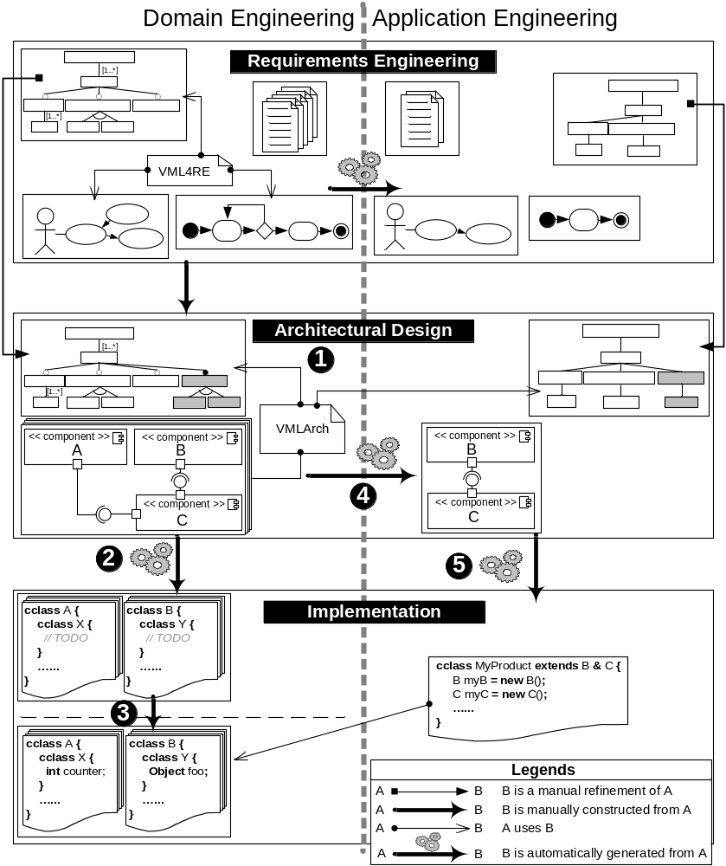
Figure 2 Overview of the TENTE approach

Domain Engineering
This section discusses the upper half of Figure 2, which is concerned with domain engineering; that is, the development of the overall SPL by defining artefacts describing all products in the SPL. The next subsection will then focus on how these artefacts are used in application engineering to derive individual product implementations.
Step 1: Architectural Design
First of all, an architectural model for the SPL is constructed (Figure 2, Label 1). This architectural model is comprised of three elements: (1) a cardinality-based feature model; (2) a UML 2.0 model, named reference architecture, which specifies the components that comprise the reference architecture and their interconnections by means of component and composite structure diagrams; and (3) a VML (Variability Modelling Language, see Chapter 4) specification.
The cardinality-based feature model (Czarnecki, Helsen, & Eisenecker, 2005b) specifies which parts of the architecture are variable and if they are mutually exclusive alternatives or simply optional features. This cardinality-base feature model is basically a refinement of the feature model created at the requirements level, using techniques and tools such as ArborCraft (Weston & Rashid, 2009) (see Chapter 3). These models must be refined because architectural decisions might introduce new variation points not addressed at the requirements engineering level. For instance, in the SmartHome case study, there are several kinds of users, with different privileges for managing the house. There are several alternatives for where to store the information regarding users and their privileges: It could be a simple XML document, a database, or some other form of storage. Which alternative to choose depends essentially on the number of users of the house. For a family house, the XML document would be enough, but for a large office building, the database option would be more suitable. Thus, software architects must refine the feature model coming from the requirements level with these new architectural variations. If Domain-Specific Languages (DSLs) were used at the requirements level for capturing domain variability, this information would need to be converted into a cardinality-based feature model, as TENTE currently supports only these latter ones. Initial work on such conversions has been presented by Stephan and Antkiewicz (Stephan & Antkiewicz, 2008).
The UML 2.0 model, which we have named reference architecture, contains the architectural design of both the commonalities and the variations of a complete family of products. This architectural model is constructed using as input the requirements-engineering specification elaborated at the domain-engineering level for the whole family of products. The reference architecture must also support all the variations specified in the requirements-level feature model. If new variations emerged during the architectural design, this shall be incorporated to the feature model at the architectural level.
In this reference architecture, coarse-grained variants are separated in different UML packages, following the AMPLE design guidelines (Sánchez et al., 2007). These packages are then combined by means of the UML merge operator, similarly to Laguna et al (Laguna et al., 2007). This operator basically combines two UML packages into a single one. Two elements of the same kind with the same name but contained in different packages (e.g. two classes named Foo placed in separated packages) are combined into a single one. This single element will have the contents of each merged element. The merging algorithm is applied recursively to the contents of merged elements. If any conflicts are detected, special rules for conflict-resolution are applied. For the sake of brevity, we refer the reader interested in these conflict-resolution rules to the UML standard specification (Object Management Group, 2005b), where they are detailed.
Each package represents an architectural increment (Hendrickson & van der Hoek, 2007), which adds new components, interfaces and so forth to an existing architecture, extending it with new functionalities. Fine-grained variants are supported using traditional techniques, such as the same interface being implemented by different components. Which variants are sufficiently coarse-grained to be encapsulated as an architectural increment and which should be considered too fine-grained depends on the specific SPL and to the best of our knowledge can only be decided based on the architect’s experience. In the SmartHome clearly limited functionalities, such as light management, are best placed in a separate package and combined by means of a merge. Variations affecting only one component, such as Dimmers having an analogue or digital display, are better placed in the same package and not separated.
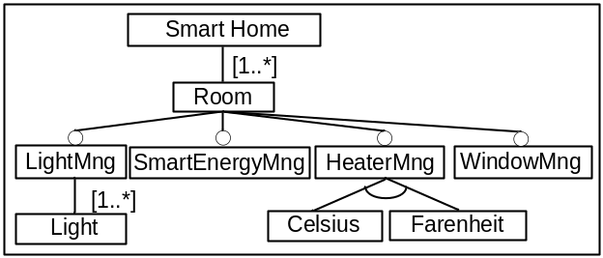
Figure 3 Cardinality-based feature model taken from the SmartHome case study
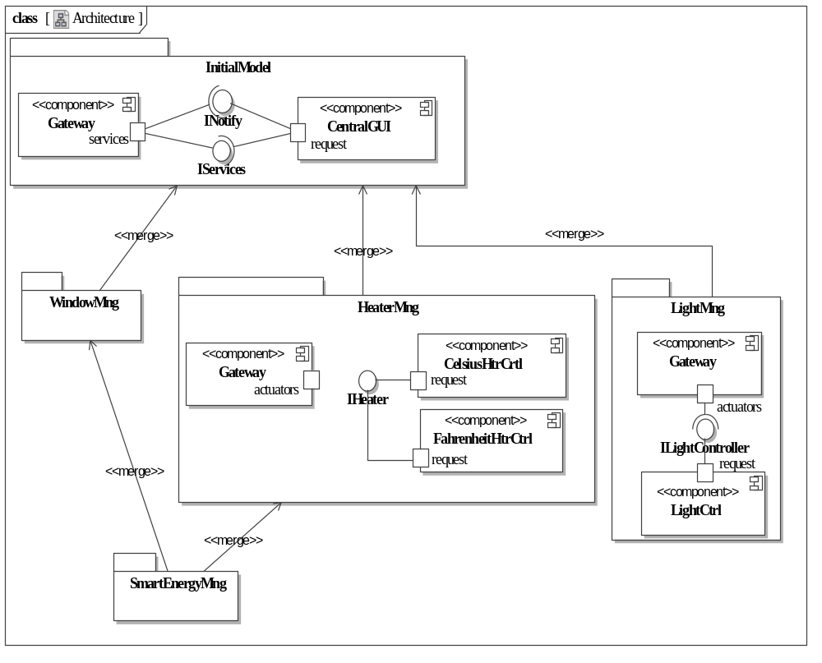
Figure 4 Component–connector model for the SmartHome case study

For modelling the software architecture, component and composite structure diagrams may be used. In domain engineering, we define the component types we need for constructing specific products. In application engineering, instances of these component types are automatically created and appropriately connected, according to the information contained in component and composite structure diagrams, for configuring specific products. By “appropriately connected” we mean that each component with a required interface must be connected to, at least, one component that requires that interface. For example, according to information contained in Figure 4, we could connect an instance of LightCtrl to an instance of Gateway. However, we could not connect an instance of the CelsiusHtrCtrl component to an instance of LightCtrl. Nevertheless, using just this information it is still possible to create incorrect configurations. For instance, if it were possible to create several instances of the Gateway component and several instances of the LightCtrl component, there is no mechanism to ensure that the each instance of the LightCtrl is connected to the proper instance of the Gateway component. Composite structure diagrams can help here sometimes (Bock, 2004), but it is not always possible. A complete solution for this issue is beyond the scope of this chapter.
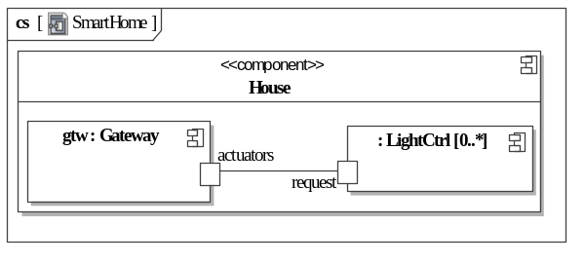
Figure 5 Example of architectural design at the domain-engineering level, taken from the Smart Home case study shows an example of feature and software architectural models for the Smart Home case study. Figure 3, the feature model for our SPL, specifies a Smart Home can have several rooms. This is normally considered structural variability, where the variable element is the number of instances of this feature that can be included in a specific product. Each room can have a different number of optional facilities, such as automatic light (LightMng), heater (HeaterMng) or window (WindowMng) management. SmartEnergyMng is an advanced optional facility that ensures windows and heaters are managed coordinatedly in order to save energy. For instance, if we order to heat a room and the windows are opened, the windows must be automatically closed in order to preserve the temperature of the room. Therefore, SmartEnergyMng is a feature that requires and extends the HeaterMng and WindowMng features. These dependencies are not explicitly shown in Figure 3, but specified separately.
Figure 4 and Figure 5 represent a bit of the whole architectural design at domain engineering level of the SmartHome case study. In Figure 4, coarse-grained variants, such as light or heater management, are divided into a hierarchy of packages interconnected by means of the UML merge relationship. Inside each package, it is specified what component types are connected and how they are connected. For instance, package Light Management, specifies that a software architecture of a SmartHome with Light Management will have at least two component types, called Gateway and LightCtrl, and that these components must be connected through the interface ILightController, which is provided by the LightCtrl component and required by the Gateway component. Thus, if a Gateway component is instantiated at the application engineering level, since it requires the ILightController interface, we would need to instantiate a component providing this interface, which, according to Figure 4 is LightCtrl. Once this latter component has been instantiated, it must be connected to the Gateway component instance initially created. This view is modelled using UML 2.0 component diagrams and it is typically constructed during domain engineering, for specifying which component types (e.g. Gateway) are available for constructing specific products.
In addition to the component view, we can also specify a component hierarchy view, depicted through composite structure diagrams, which specifies how components are nested and how many instances of each component type are allowed in a specific software architecture. For instance, Figure 5 specifies each instance of the House component has nested specifically one instance, which is called gtw, of the Gateway component, and that this instance is connected to a variable number of LightCtrl instances. This diagram is included in the LightMng package, but not shown in Figure 4 for the sake of clarity. In general, each UML package can contain several UML diagrams.
The link between the feature model and the reference architecture is established using VML4Arch (Variability Modelling Language for architecture) (see Chapter 4 and also (Loughran et al., 2008; Sánchez, Loughran, Fuentes, & Garcia, 2008), a language for connecting variability specification with variability realisation. A VML4Arch specification contains all the information required for automatically deriving the architectural model of a specific product from the reference architecture. For each variant, special primitives specify which actions must be carried out if this variant is selected or deselected. Figure 6 shows an excerpt of a VML4Arch specification for the example of Figure 3–Figure 5.
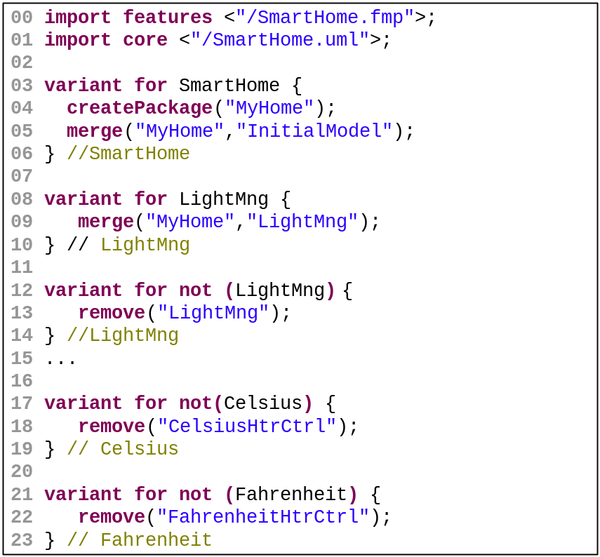
Figure 6 VML specification for the architectural design of Figure 3–Figure 5
This specification specifies how to obtain the architecture of a specific product given a configuration of the architectural feature model. This product derivation process is as follows: First of all, a new UML package representing the final product being derived is created. This package is called MyHome and it is initially empty. This empty package would merge those packages that correspond to selected features, e.g. LightMng. The piece of code for creating this package (Figure 6, line 04) is placed into the SELECT clause of the SmartHome feature, which is the root feature of the architectural feature model depicted in Figure 3. In this case, this package merges the InitialModel package (Figure 6, line 05), which represents the minimum and core functionality that any SmartHome must have. Since this feature is always selected, this piece of code is always executed and the MyHome package is always created and a merge relationship is initially created between this package and the InitialModel package.
When coarse-grained features encapsulated into UML packages, such as LightMng, are selected (Figure 6, line 08-10), a new merge relationship is added between the package representing the final product, MyHome, and the package representing the coarse-grained feature (e.g. LightMng). This means that the contents of this package will be included in the final product. In case a coarse-grained feature represented by a UML package is not selected, e.g. LightMng (Figure 6, line 12-14), the corresponding package is removed. We could let this package be there, since if no merge relationship exists between this package and the package representing the whole product, i.e. MyHome, the contents of this coarse-grained feature will not be included in the final product anyway. Nevertheless, in order to reduce the size and complexity of the models, we have opted for removing it.
Fine-grained variations are managed through different VML4Arch operators. We refer the interested reader to Chapter 4 for a more comprehensive list of such operators. For instance, the variation on the heaters operating in Celsius or Fahrenheit is a fine-grained feature that is not encapsulated into separate UML packages. In this case, two different implementations of the IHeater interface are provided, one for the Celsius case and the other one for the Fahrenheit case (see Figure 6). We follow a negative variability approach and remove the CelsiusHtrCtrl or the FahrenheitHtrCtrl component in case the corresponding feature is unselected.
This VML4Arch specification might be constructed from scratch at the architectural level or by means of refining a VML4RE specification produced at the requirements engineering level. This will depend on whether architectural models are constructed from scratch at architectural design time or by refining models created at requirements engineering. For instance, the component and connector view is usually constructed for the first time at the architectural level. In this case, a VML4Arch specification must also be created from scratch. On the other hand, sequence diagrams illustrating how the different components of a software architecture interact in order to fulfil a certain use case are often obtained by refining similar sequence diagrams that were elaborated at the requirements engineering stage. In this case, the VML4Arch specification might be obtained by refining the corresponding VML4RE specifications. At this point, TENTE only supports the component-and-connector view. Therefore VML4Arch specifications must be constructed from scratch since there are no similar models coming from the requirements engineering level.
Step 2: Transformation of architectural models into implementation
From the reference architecture, part of the implementation is automatically generated (Figure 2, Label 2). As TENTE does currently not support behavioural models as part of the reference architecture, only skeletons of components and infrastructure logic for connecting them can be generated. All method implementations are left empty for manual completion by the SPL developer. The separation of variants achieved at the modelling level through the use of package merge is preserved at the implementation level using CaesarJ family classes and mixin composition (Aracic et al., 2006; Gasiunas & Aracici, 2007). CaesarJ is a subset of the ECaesarJ language described in Chapter 6 (the reader is invited to refer back to that chapter for a more detailed introduction to CaesarJ terminology).
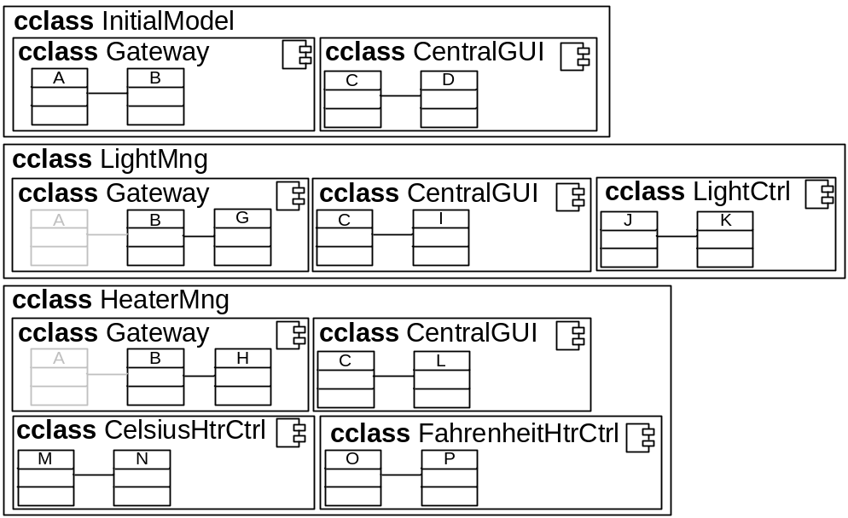
Figure 7 Generation of a two-level nesting of family classes
Figure 7 illustrates the code-generation strategy. The main idea is that each coarse-grained feature represented by a UML package is encapsulated into a family class, which is the construction provided by ECaesarJ for encapsulating coarse-grained features. Family classes were introduced in Chapter 6. A family class is basically a class containing a set of virtual classes, which are declared in the same way as Java inner classes, but differently from inner classes they can be extended in the subclasses of the family class. Such extensions can be composed by propagating mixin composition: when composing family classes their virtual classes with equal names are again composed by the same composition semantics. The resulting family class can be intuitively seen as result of merging the virtual classes and their relationships. Because the semantics of propagating mixin composition and package merge are, thus, sufficiently close, we can use a more or less direct mapping in our code generation. Family classes are depicted in Figure 7 as rectangles whose name is preceded by the CaesarJ keyword for family classes cclass. For instance, the LightMng and HeaterMng architectural increments would lead to the creation of two family classes (see Figure 7), named equally LightMng and HeaterMng.
Each UML package, or architectural increment, is comprised of a set of interconnected components. Each component (e.g. Gateway, LightCtrl) is implemented as a bundle of classes. Thus, each architectural component is also implemented as a family class, where the classes that implement a component are virtual classes of that family class. This family class corresponding to a component is nested in the family class corresponding to the package where the component is contained. Thus, each component is a second-level family class contained inside a first-level family class. For instance, the family class for LightCtrl component is placed into the family class corresponding to the LightMng package, which is the package that contains this component.
This strategy allows components to be refined through different architectural increments, or coarse-grained features. For instance, the LightMng feature can refine the Gateway component defined in the InitialModel package, in order to add to the Gateway the functionality regarding light manipulation. Internal classes of architectural components can also be refined, as they are also represented as virtual classes. This two-level family classes schema also enables components belonging to one architectural increment to be developed, tested and compiled independently of the other components of the family of products. The main benefit of making components independent of each other is that it is thus possible to change the business logic of one component without modifying the other components of the application.
A more detailed description about how the different UML 2.0 elements used for specifying software architectures are transformed into implementation artefacts on CaesarJ is provided in Table 1. For a more in-depth description containing low-level technical issues, we refer the interested reader to (Nebrera et al., 2008)
Table 1 Correspondence between UML 2.0 and CaesarJ artefacts
Architecture | Implementation | Description
Package | First-level family class | A package is mapped into a family class, which will contain the result of transforming the elements the package contains. A new Java package is also created for each architectural package in order to keep the implementation files corresponding to different packages logically and physically separated and to avoid name conflicts.
Merge relationship | Inheritance between first-level family classes. | A merge relationship between packages is mapped into an inheritance relationship between family classes. The merged package will act as the parent and the merging package as the child in the inheritance relationship. Merging of multiple packages is supported by CaesarJ, since CesarJ allows multiple inheritance by means of propagating mixin composition.
Component | Second-level family class | Components are mapped into second-level family classes which are contained in the first-level family class that results of transforming the architectural package where the component is contained. A new Java package, contained in the Java package that results of transforming the architectural package where the component is contained, is also created in order to maintain the implementation files of the component physically and logically separated and to avoid name conflicts.
Component inner class | Virtual class contained in a second-level family class. | A component inner class is mapped into a virtual inner class, which is contained in the family class result of transforming the architectural component that contains the inner class. Component inner classes which serve as type of a port are not transformed following this rule.
Interface | Interface | An architectural interface is mapped to a common Java interface. CaesarJ family classes do not support the definition of interfaces inside them, thus, a generated Java interface is placed in the Java package corresponding to the transformation of the architectural package that contains this interface, but it is placed outside the family class corresponding to this architectural package.
Port | Inner virtual class contained in a second-level family class plus and attributed contained in that second-level family class | A port is an attribute of a component with a specific type, which is a component inner class. Thus, the inner class is transformed into a virtual inner class, which is contained in the second-level family class that results of transforming the architectural component that contains the inner class. The port itself is mapped into an attribute contained in the second-level family class that results of transforming the architectural component that contains the port. This attribute has as type the virtual inner class previously generated. In addition, a getter method is generated in the second-level family class that results of transforming the architectural component that contains the port for retrieving the attribute corresponding to the port.
Required relationship between a port and an interface | A list of interfaces, plus a connect method. | A required relationship between a port and an interface is transformed into an attribute of type list. The type of the elements of the list is the Java interface that corresponds to the transformation of the architectural interface that the port requires. Moreover, a connect method for connecting the implementation of two components through a port is generated.
Provided relationship between a port and an interface | Interface implementation | A provided relationship between a port and an interface is transformed into an implements relationship between the inner virtual class which corresponds to the transformation of the inner class that serves as type for the port and the Java interface result of transforming the architectural interface.
Attribute | Java attribute plus getters and setters | Attributes of architectural components and classes are mapped into a Java attribute plus the corresponding pair of getter and setter methods (depending upon attribute visibility and kind, e.g. read-only attributes do not generate a setter method). Attributes of architectural interfaces only generates the pair of getter and setter method, since Java does not allow the declaration of attributes in interfaces. An attribute is contained, in the implementation, in the result of transforming the architectural classifier that owns this attribute.
Method | Java method | Methods of architectural components, interfaces and classes are mapped into Java methods. A method is contained, in the implementation, in the result of transforming the architectural classifier that owns this method.

Figure 8 shows an example of code generated from a very simple fragment of code. It is not the authors’ intention that the reader can capture all the details of this process from the figure. Rather, the figure is intended to illustrate that although the mapping between a hierarchy of UML packages connected by merge relationships and CaesarJ family classes is conceptually simple, the implementation of the code generator is not so simple due to: (1) complexity of the UML metamodel; (2) each piece of code is influenced by several elements from the model, so we need to perform complex navigations through the source model when generating the code.
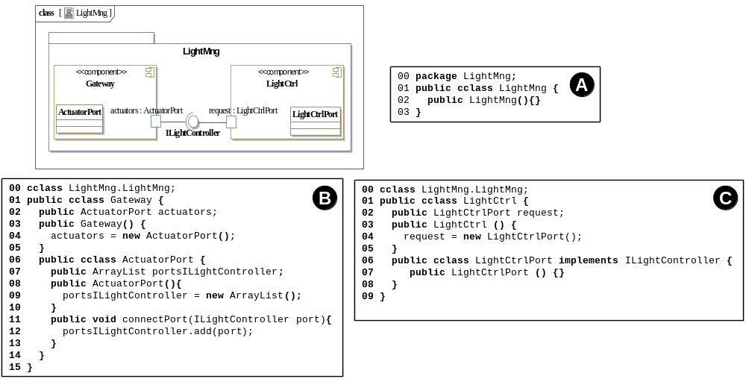
Figure 8 Example of CaesarJ code generated from a simple model fragment
First of all, a new first-level family class and a Java package (Figure 8, label A, lines 00-03) are generated as result of transforming the LightMng package. Then, components are transformed. Each component is placed in a separate file to allow different developers to work independently on each component (Figure 8, labels B and C). Each component is transformed into a second-level family class (Figure 8, label B, line 01 and label C, line 01).
Then, the contents of each component are transformed into CaesarJ code. In Figure 8, each component has a port plus a class that serves as type of the port. For instance, the actuators port is typed by the ActuatorPort class. Similarly, the request port of the LightCtrl class is typed by the LightCtrlPort class. These classes, when transformed into code, results in a third-level family class (Figure 7, label B, lines 06-14 and label B, lines 06-08).
Each port is then transformed into an attribute of the second-level family class that results from transforming the component that contains the port. The type of this attribute is the class resulting from transforming the UML class that serves as type for the port (Figure 8, label B, line 02 and label C, line 02).
Finally, we must generate a different infrastructure depending on if the port provides or requires some interface. In case a port provides an interface, the class that types port must implement the interface provided by the port (Figure 8, label C, line 06). If the port requires an interface, certain infrastructure logic must also be generated (Figure 8, label B, lines 07-13).
The next step in our process would be to manually complete these code skeletons automatically generated from the models.
Step 3: Domain engineering implementation
Each component skeleton so generated needs to be manually completed with its corresponding business logic (Figure 2, Label 3). As a result, a set of components implementing the family of products is obtained. We only need to appropriately instantiate and connect these components in order to obtain a specific product. This is addressed at the application engineering level. This step completes the domain engineering level.

Application Engineering
At the application-engineering level, a specific product is configured by selecting those features that must be included in that product and subsequently instantiating and connecting components according to that selection of features.
Step 4: Derivation of a specific architectural model
The first step in our process at the application engineering level is the creation of a configuration of the architecture-level feature model, i.e. a valid selection of variants to be included in a specific product. This configuration is derived from a configuration model constructed at the requirements-engineering level. Hence, if the feature model has been refined at the architectural level, the new introduced variations would need to be bound at the architectural level, probably using some high-level information gathered at the requirements level. For instance, coming back to the XML file vs. database example (see Section 5.1, step 1), this variation would need to be configured at the architectural level. Software architects may use information gathered at the requirements level, such as that the house will have a small number of inhabitants or that the deployment cost should be as low as possible, for choosing between alternatives.
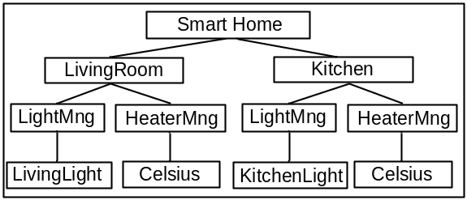
Figure 9 Configuration model for constructing a specific product
For instance, a customer could opt to buy a Smart Home with two automated rooms, a living room and a kitchen. For the two rooms, automatic control of lights and heaters is selected. The user opts for buying heaters operating in Celsius. These selections serve to create a configuration of the feature model depicted in Figure 3. Figure 9 shows this configuration model.
Using this configuration, the architectural model of the desired product might be automatically derived from the reference architecture, by executing the VML4Arch specification. A VML4Arch specification is compiled into a set of model transformations that actually implement the product derivation process, as described in Chapter 4 and in Sánchez et al (Sánchez et al., 2008). Cloned features, such as LivingRoom or Kitchen, and cloned sub feature models and configurations, such as the subtrees below LivingRoom or Kitchen, are currently not managed by VML4Arch. We have planned to address this issue as part of our near future work. Thus, the part of the VML specification regarding clonable features must be manually executed currently. A complete implementation of VML4Arch, including management of clonable features, is part of our near future work.
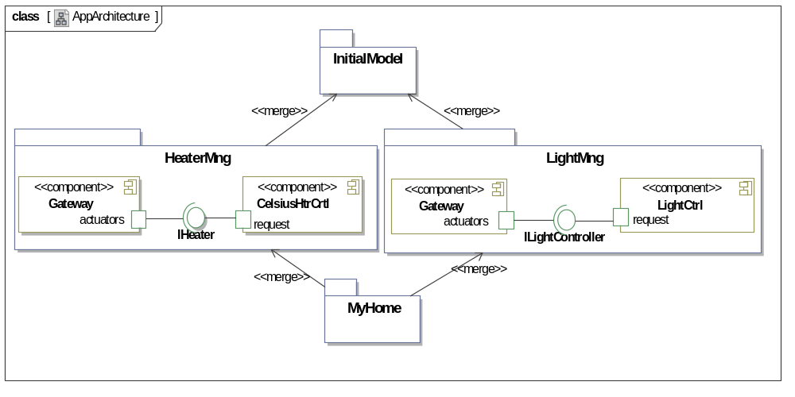
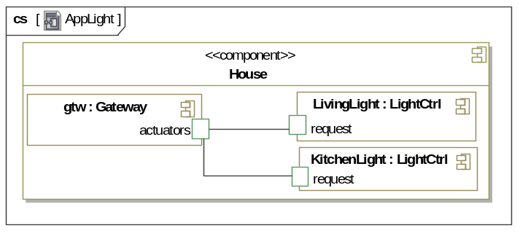
Figure 10 Architectural design at application engineering level
As a result, the architectural model depicted in Figure 10 for the desired product is obtained.
First of all, as already commented in Section 5.1, Step 1, a new package called MyHome, representing the specific product being constructed, is created. As already commented, the goal of this package is to combine all coarse-grained selected features. This package is initially empty and merges all the packages corresponding to selected features. For instance, in Figure 10, it merges LightMng and HeaterMng, as these packages correspond to selected features. It should be noticed that some optimizations are applied. More specifically, redundant merge relationships are removed for the sake of simplicity.
The generated application-engineering architecture contains only those packages and components corresponding to selected features. For instance, the package corresponding to the WindowMng option has been removed. In the same way, the FarenheitHtrCtrl has been removed from the HeaterMngCtrl, as defined by the VML4Arch specification (see Figure 6, Line 02). Component instances are also created and appropriately connected according to the user configuration. For example, one instance of the LightCtrl component is created each time the Light feature (see Figure 3) is instantiated, or in feature-model terminology cloned, in a configuration model. Therefore, according to the configuration model shown in Figure 9, two instances of the LightCtrl component must be created. These component instances will have the same name as the corresponding cloned feature. These new created instances can be connected to other component instances. In our case, the LightCtrl instances must be connected to the gtw instance of the Gateway component, according to our architectural design. This connection is specified by means of VML4Arch operators (see Chapter 4 for more details). Notice that, as already commented, the current VML4Arch implementation does not deal with these issues yet. Figure 10 (lower part) shows the composite structure diagram corresponding to the result manually interpreting these rules.
Step 5: Derivation of a specific implementation
The software architectural model obtained in the previous step is automatically transformed into a complete implementation in CaesarJ, using a code generator. Figure 11 shows an excerpt of the code generated at application engineering level.
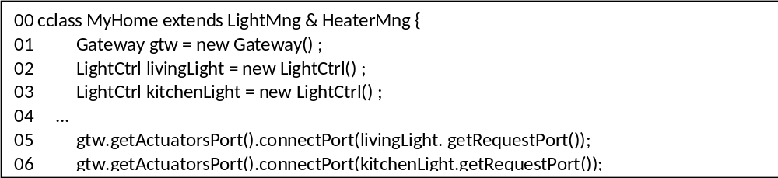
Figure 11 Application engineering implementation
This code generator basically works as follows:
A new family class corresponding to the empty package added at the application engineering level (i.e. MyHome for our example) is created (Figure 11, line 00). This empty family class represents the whole product and it would inherit from the first-level family classes that were generated at domain engineering level and that corresponds to the UML packages merged by the empty package, which is called MyHome in our example. For instance, according to Figure 8, the family class MyHome would inherit from the first-level family classes HeaterMng and LightMng (Figure 11, line 00), which were generated as result of transforming the LightMng and HeaterMng packages, which are the packages merged by the leaf package MyHome.
Then, the code for creating the component instances which are required for assembling a specific product is generated (Figure 11, Lines 01–03). Each instance receives the same name the component instance has in the model. For instance, as result of processing the composite structure diagram depicted in Figure 10, the code depicted in lines 01-03 of Figure 11 is generated. In case a component instance has attributes and these attributes were initialized in the model to a certain value, a call to the corresponding setter method would be generated.
Finally, the code for appropriately connecting these component instances is generated (Figure 11, Lines 05–06). Basically, for each pair of connected component instances, a call to a connect method of the component instance that requires the interface is generated. As parameter of this call, the component instance providing the interface is used. For instance, as result of processing the information contained in Figure 10, lines 05 and 06 of Figure 11 would be generated. These lines serve to provide an implementation of the ILightController interface to the instance of the Gateway component and connect the gateway to the software for controlling light brightness.
Table 2 describes the complete correspondence between UML 2.0 elements and CaesarJ elements for the application engineering level. For further examples of these correspondences, we refer the interested reader to Nebrera et al (Nebrera et al., 2008).
Architecture | Implemenation | Rationale
Leaf package | Final family class | The new architectural package added to the architectural model at the application engineering level, which is a leaf package is transformed into a new first-level family class, which will serve to instantiate the final product. This generated first-level family class will inherit from the first-level family classes corresponding to the transformation of the architectural packages this leaf package merges.
Component Instance | Instantiated attribute in the final family class | Each component instance created in the architectural model at the application engineering level is transformed into an instantiated attribute, which is contained in the final family class. This attribute has as type the second-level family class corresponding to transformation of the architectural component, which is the type of the component instance.
Inner class Instance | Instantiated attribute in the final family class. | Each component inner class instance created in the architectural model at the application engineering level is transformed into an instantiated attribute, which is contained in the final family class. This attribute has as type the virtual inner class corresponding to transformation of the component inner class, which is the type of this instance.
Attribute initialization | Call to a setter method | Each initialization of an attribute of an instance, at the architectural level, is transformed into a call to the setter method for updating the corresponding attribute of the family-class result of transforming the architectural classifier that contains the attribute.
Component Instances connection | Call to a connect method | A connection between two component instances is transformed into a call to the connect method of the inner virtual class result of transforming the architectural port that requires the interface through these components are connected. As parameter of the connect method, the attribute corresponding to the transformation of the port that provides the interface through these components are connected, is used.
Table 2 Correspondence between UML 2.0 and CaesarJ artefacts at the application engineering level.
We would like to point out that traceability information for being stored in the AMPLE Traceability Framework (ATF, see Chapter 8) is automatically generated by the TENTE code generators. We refer the interested reader to Chapter 8 and (Nebrera et al., 2008) for more information about how the code generators automatically create trace links during the code-generation process.
Finally, we would like to point out that TENTE was also successfully applied to the Sales Scenario case study (see Chapter 2). Similarly to the Smart Home case study, we firstly produced a feature model. Then, we constructed a feature-oriented architectural model following the AMPLE guidelines (Sánchez et al., 2007), where coarse-grained features were encapsulated into separate UML packages adequately combined by means of merge relationships.
The main difference with the Smart Home case study was that fewer features were encapsulated into UML packages. The Sales Scenario entails mainly fine-grained variations whose encapsulation in separate packages is not recommended. Fine-grained variants are features which imply small changes in architectural models. For instance, customer rating only required the addition of a couple of fields to a data structure for representing customers, and the modification of the internal logic of a couple of methods. The encapsulation of these variations in separate UML packages would lead to a software architecture with a large number of small UML packages, and, in addition, complex dependencies between them. So, this might hinder scalability.
Therefore, different from the Smart Home case study, we use negative variability for dealing with a large number of features of the Sales Scenario. Optional elements that should not be included in a final product were simply automatically removed by VML4Arch during the product derivation process.
Next, we run the TENTE code generator for creating the code skeletons of the reference implementation. In this case, around the 30% of the final code was obtained, a lower amount than for the Smart Home. The reason is that Sales Scenario components are not as simple as Smart Home components, which, are basically sensors and actuators comprised of simple setter and getter methods. In the Sales Scenario case study, components required a higher amount of business logic, which had to be manually added after the generation of the code skeletons.
Then, we created several configurations of the feature model attending to different user needs. We used these configurations for creating specific software architectures by executing the VML4Arch specification. These specific software architectures were given as input to the TENTE code generator, which produced the 100% of the code required for the final applications.
As an advantage of applying TENTE to the Sales Scenario, a certain improvement on modularization was obtained, although lower than in the Smart Home case since fewer features were suitable to be encapsulated into separate modules. A more important advantage was that we were able to automate several part of the process, such as the whole application engineering level or the generation code skeletons, due to the use of model-driven techniques. But, unlike other approaches, such as MAPLE (see Chapter 11), software engineers had not to deal with general-purpose model transformation languages. This was so because: (1) the same code generators as for the Smart Home case study were reused; and (2) VML4Arch allows software architects to automate the product derivation process using a high-level user-friendly language that hides particularities and intricacies of general-purpose, and low-level, model transformation languages to software architects.
The next section provides a critical discussion on benefits and pitfalls of our approach.

Discussion
In Sect. 3, we identified three key requirements for product-driven SPLs. The TENTE approach presented above meets these requirements in the following ways:
- Strong support for variability identification, specification and design. Variability specification is achieved by using cardinality-based feature models to represent the space of different products making up the SPL. Such feature models may be manually constructed or they may be the result of using tooling such as ArborCraft presented in Chapter 3. These feature models may be refined to include architectural or design variations. Finally, VML* languages (cf. Chapter 4) and UML 2.0 models are used to model how individual variants are realised in requirements, architecture and design models.
- Strong support for feature management and composition throughout the SPL. Coarse-grained features are encapsulated in TENTE in their own packages at the modelling level and in their own family classes at the implementation level. Thus, for these features all affected elements are always encapsulated in one modular unit, making identification, tracing, and composition relatively easy tasks. However, this does not make tracing unnecessary. While coarse-grained features are nicely encapsulated, architects and designers still have a large amount of flexibility in how they implement each feature. This is even more true for fine-grained features, which can use any technique architects and designers can think of to allow for their variation. Some features may not even be represented by a single entity in architecture or design, but rather be scattered over a number of entities. For example, the Room feature of the SmartHome case is represented by an attribute in each device object, recording the unique ID of the device’s room, and by a data structure in the Gateway, maintaining the relationship between room IDs and floor IDs. However, even in these cases there is some support for tracing in TENTE, as the relationships between features and model elements are explicitly modelled in VML specifications.
- Strong automation support for application engineering. Based on the preparation work done by the SPL engineer at the domain-engineering level, TENTE almost completely automates the application-engineering process. The main manual step is the creation of a configuration for the product; that is, the selection of features to be included. Based on such a configuration, the product architecture, design, and implementation are generated completely automatically. Additionally, TENTE provides some automation support for domain-engineering, generating CaesarJ skeleton code from the application architecture. According to measurements performed in the AMPLE project (Nebrera et al., 2008), between a 30-70% of the code required at domain engineering level can be automatically generated. The variation on the percentage depends on how business logic is contained in each component.
We also discussed in Sect. 3 the distinction between pro- and reactive SPLs and stated that, ideally, every SPL engineering approach should support both types of SPL development. TENTE is clearly suited for pro-active development of SPLs. It can also be used for reactive SPLs, but in this case the existing implementations and designs will need to be refactored to fit the form required by the TENTE approach. What implications this has for the cost of reactive SPL development with TENTE still needs to be studied.
Regarding the challenges for SPL engineering identified in Chapter 1, some of them are addressed by the individual techniques used within TENTE. For example, Challenge 1 is mainly addressed by the requirements-engineering techniques presented in Chapter 3 and used in TENTE. Beyond these challenges, which are discussed in more detail in the respective technology chapters, TENTE specifically addresses Challenges 3, 4 and 6, as discussed below:
Challenge 3: “Facilitating the creation of configurable and reusable core assets which emerge from the reference architecture”. This is addressed in TENTE through its automation support at the domain-engineering level. Once a reference architecture has been defined, TENTE can generate CaesarJ skeleton code that can form the basis for configurable and reusable core assets to be used in the construction of individual products. The automation is partial in the sense that actual business logic still needs to be implemented manually and added to the appropriate places of the generated code.
Challenge 4: “Supporting automation of product construction as far as possible”. This is identical to the third requirement expressed in Sect. 3. As already discussed above, TENTE provides complete automation of product construction. The only manual step is the creation of a product configuration, which is used as an input to the product-construction transformation chain.
Challenge 6: “Supporting the ability to keep track of information flow, linking artefacts throughout the PLE process with decision rationale”. This is partially supported by TENTE in that coarse-grained features are kept well encapsulated at all stages of development, simplifying information tracing for these features. Furthermore, the explicit representation of the relation between features and their effects on architecture and design models also adds tracing information.
A current limitation of TENTE as presented above is that support for managing cardinalities of features is not implemented yet in VML4Arch. Cardinality-based feature models would support this through a configuration process called staged configuration (Czarnecki et al., 2005b), where different rooms would be represented as different clones of the Room feature. The main problem here is that we need to distinguish between clonable features, i.e. features with upper bounds higher than 1, such as Room (see Figure 2) and normal features, such as LightMng. Moreover, the cloning of a feature like Room also implies the replication of the sub-tree that has this feature as root, which implies the selection of features contained in this subtree should only affect to that instance of the features, and not to other clones. Thus, it would be possible to have different configurations for different rooms of a Smart Home. For supporting this, VML must be extended with new primitives beyond SELECT/UNSELECT, such as CLONE, and also provide some linguistic support for accessing to the context of the feature, such as getContextClone. This linguistic support and its corresponding implementation is part of our current ongoing work.
Another limitation of TENTE is that it does not support useful negative variability mechanism for fine-grained variations at the implementation level. We can remove components at the modelling level, which implies these components are excluded from the build files. But, if we remove operations at the application engineering level, these operations are not removed from the corresponding CaesarJ family classes. This can be solved using tracing information for knowing which operations might be removed at application engineering, i.e. what operations are optional, and design a mechanism for removing these operations at the code level. A straightforward solution would be to enclose these operations in some kind of conditional compilation block or a code generation template. Nevertheless, enclosing variable classes in code generation templates often hinders development and testing, as we need to generate the code before testing it. So, we aim to develop something similar to VML, but using program transformation instead of model transformation, in order to be able to bind variability at the code level trying to affect normal classes as little as possible.

Summary and Outlook
In this chapter we have presented TENTE, an approach that combines a number of the individual techniques presented in previous chapters to support product-driven SPL engineering. TENTE represents one possibility to select and combine these techniques, focusing on automatic product derivation and encapsulation of coarse-grained features throughout the product line. There is a whole spectrum of other contexts ranging from product-driven SPL development as discussed here to solution-driven SPL development as discussed in the next chapter. Each of these contexts (and hence each individual SPL project) may require a different selection and combination of techniques. The TENTE approach as presented in this chapter should therefore be viewed as an example of a useful selection and combination for product-driven SPL development rather than a definitive approach for all SPL development.
Still, as such, TENTE provides a useful approach for developing SPLs in a product-driven context, especially where the number of potential variants or products can well be estimated in advance and where more advanced implementation techniques, such as ECaesarJ can be used. For these cases, SPL developers can benefit from the clear structure, tool support, and systematic maintenance of feature-oriented modularity provided by TENTE.
As future work, we have planned to extend the TENTE code generators for considering other UML diagrams, such as deployment diagrams or protocol state machines.

References
(Aracic et al, 2006) I. Aracic, V. Gasiunas, M., Mezini and K. Ostermann. “An Overview of CaesarJ” Transactions on Aspect-Oriented Software Development I, A. Rashid and M. Aksit (Eds), LNCS 3880: 135-173, February 2006.
(Bock, 2004) Conrad Bock. "UML 2 Composition Model", Journal of Object Technology (JOT), 3(10): 47-73, November-December 2004.
(Czarnecki et al, 2005) K. Czarnecki , S. Helsen and U. W. Eisenecker. “Staged Configuration through Specialization and Multilevel Configuration of Feature Models”. Software Process: Improvement and Practice 10(2):143-169, January-March 2005.
(Czarnecki and Antkiewicz, 2005) K. Czarnecki and M. Antkiewicz. “Mapping Features to Models: A Template Approach Based on Superimposed Variants”. Proc. of 4th Int. Conference on Generative Programming and Component Engineering (GPCE), R. Glück and M. R. Lowry (Eds.), LNCS 3676: 422-437, Tallinn (Estonia), September-October 2005.
(Gasiunas and Aracic, 2007) V. Gasiunas and I. Aracic. “Dungeon: A Case Study of Feature-Oriented Programming with Virtual Classes”. Proc, of the 2nd Workshop on Aspect-Oriented Product Line Engineering (AOPLE), 6th Int. Conference on Generative Programming and Component Engineering (GPCE), Salzburg (Austria), October 2007.
(Greenwood et al., 2007) P. Greenwood, T. T. Bartolomei, E. Figueiredo, M. Dósea, A. F. Garcia, N. Cacho, C. Sant'Anna, S. Soares, P. Borba, U. Kulesza and A. Rashid. “On the Impact of Aspectual Decompositions on Design Stability: An Empirical Study”. Proc. of the 21st European Conference on Object-Oriented Programming (ECOOP), Erik Ernst (Ed), LNCS 4609: 176-200, Berlin (Germany), July-August 2007.
(Fuentes et al, 2009) L. Fuentes, C. Nebrera and P. Sánchez. "Feature-Oriented Model-Driven Software Product Lines: The TENTE approach" Proc. of the Forum of the 21st International Conference on Advanced Information Systems (CAiSE), Amsterdam (The Netherlands), June 2009. In print.
(Gomma, 2004) Hassan Gomaa. “Designing Software Product Lines With UML”. Addison- Wesley, July 2004.
(Hendrickson and van der Hoek, 2007) S. A. Hendrickson and A. van der Hoek. “Modeling Product Line Architectures through Change Sets and Relationships”. In Proc. of the 29th Int. Conference on Software Engineering (ICSE):189-198, Minnesota (Minneapolis, USA), May 2007.
(Kang et al, 1990) K. Kang, S. Cohen, J. Hess, W. Nowak and S. Peterson. “Feature-Oriented Domain Analysis (FODA) Feasibility Study”. Technical Report No. CMU/SEI-90-TR-21, Software Engineering Institute (SEI), Carnegie Mellon University, Pittsburgh, Pennsylvania 1990.
(Laguna et al, 2007) M. A. Laguna “Seamless Development of Software Product Lines”. Proc. of the 6th Int. Conference on Generative Programming and Component Engineering (GPCE): 85-94, Salzburg (Austria), October 2007.
(Loughran et al, 2008) N. Loughran, P. Sánchez, A. Garcia and L. Fuentes. “Language Support for Managing Variability in Architectural Models”. Proc. of the 7th Int. Symposium on Software Composition (SC), C. Pautasso and É. Tanter (Eds), LNCS 4954:36-51, Budapest (Hungary), April 2008.
(Nebrera et al, 2008) C. Nebrera, P. Sánchez, L. Fuentes, C. Schwanninger, L. Fiege, M. Jäger. “Description of model transformations from architecture to design”. AMPLE Deliverable 2.3, September 2008.
(Sánchez et al, 2007) P. Sánchez, N. Gámez, L. Fuentes, N. Loughran and A. Garcia. “A Metamodel for Designing Software Architectures of Aspect-Oriented Software Product Lines”. AMPLE Deliverable D2.2, September 2007.
(Sánchez et al, 2008) P. Sánchez, N. Loughran, L. Fuentes and A. Garcia. “Engineering Languages for Specifying Product-derivation Processes in Software Product Lines”. Proc. of the 1st Int. Conference on Software Language Engineering (SLE), D. Gašević , R. Lämmel, and E. Van Wyk (Eds), LNCS 5452: 188-297, Toulouse (France), September 2008.
(Stephan and Antkiewicz, 2008) M. Stephan and M. Antkiewicz. “Ecore.fmp: A tool for editing and instantiating class models as feature models”. ECE, University of Waterloo, Technical Report #2008-08, May 2008.
(Trujillo et al, 2007) S. Trujillo, D. S. Batory and O. Díaz “Feature Oriented Model Driven Development: A Case Study for Portlets”. Proc. of the 29th Int. Conference on Software Engineering (ICSE):44-53, Minneapolis, (Minnesota, USA), May 2007.
(UML, 2005) Object Management Group (OMG), “Unified Modeling Language: Superstructure version 2.0 (formal/05-07-04)”, August 2005.
(Völter and Groher, 2007) M. Völter and I. Groher. “Product Line Implementation using Aspect-Oriented and Model-Driven Software Development”. Proc. of the 11th Int. Software Product Line Conference (SPLC): 233-242, Kyoto (Japan), September 2007.
(Weston and Rashid, 2009) N. Weston and A. Rashid “ArborCraft: automatic feature models from textual requirements documents”. In Proceedings of the 15th Workshop on Early Aspects (EA), 8th Int. Conference on Aspect-Oriented Software Development:45-46, Charlottesville (Virginia, USA), March 2009.
(Ziadi and Jézéquel, 2003) T. Ziadi and J. M. Jézéquel. “Software Product Line Engineering with the UML: Deriving Products”. Software Product Lines: Research Issues in Engineering and Management, T. Käkölä, J. C. Dueñas (Eds):557-588. Springer, October 2006.

pure:variants: (http://www.pure-systems.com)
Gears-BigLever Software Inc: (http://www.biglever.com)
TENTE is the Spanish name for Lego. We have selected this name because we view an SPL as a Lego game: it is about constructing specific products from prebuilt blocks.
Feature-orientation can be considered as a special form of aspect-orientation. The exact relation between the two approaches is not relevant for this chapter. We will use feature-orientation throughout this chapter.
This is a feature model at the architecture level. For our concrete example, no refinements were required from the requirements-level feature model.
Normal classes might conceptually be used, but, due to low-level technical details of the CaesarJ language, it is safer to consider them as family classes.

